Carlos Perez Rosas Adrian Cadena

December 12, 2022

# Project Summary

We created a program that would take data from an air pollution csv dataset in the United States from 2000 to 2021 to compare states and the total Air Quality index(AQI) from one of the 4 different types of air pollution within the 47 states available per selected year. In addition, we made it possible to search for an individual state to check the total AQI from 2000 to 2021 of the specific type of pollution selected. We accompanied both of these functions with illustrations, for the comparison it will create a bar graph of the selected years showing the top polluting states ranging from 5, 10, or 15 states that can be shown in the bar graph for the selected year. For the individual state search, we also made a bar graph that illustrates the total AQI per year. The problem we aim to resolve with the program is to illustrate the levels of pollution for each state and compare whether they have increased or decreased over the last two decades. This can potentially help environmentalists focus on U.S. States that have unhealthy to hazardous levels of pollution.

Our scope for this program is to show two comparisons: the AQI each year for an entire state or the top polluting states in a given year. The csv dataset contains data ranging from individual days, months, and counties within a state. To fit our scope, we created a new csv file that averages the AQI of each state for each year. For our purpose we are focusing on Year, State O3 AQI, CO AQI, SO2 AQI, and NO2 AQI. Air Quality Index values range from 0 to 500, 0 being good and 500 being hazardous.

Link to the original csv dataset: [US Pollution 2000-2021](https://www.kaggle.com/datasets/alpacanonymous/us-pollution-20002021)

# Program User Instructions

For the program to run, please use simple pollution file_2000_2021.csv Also the user will need to install the following packages:

matplotlib pandas

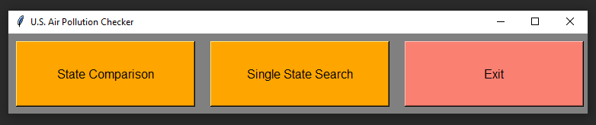numpy (should automatically install with pandas in PyCharm)

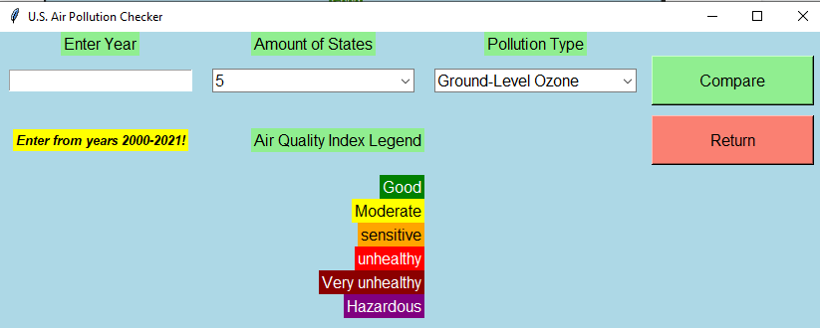When running the program the first GUI illustrated above will be created with 3 different options that can be selected by the user. The first option is called “State Comparison” which when selected, will close the current GUI and open a new GUI for the state comparison functionality of the program. The second option is called “Single State Search” which when selected, will close the current GUI and open a new GUI for the individual state search functionality of the program. The third option called “Exit” will terminate the program and any opened graphs.

After selecting the option “State Comparison” the program will create the GUI illustrated above containing a year entry box on the left under the “Enter Year” label

where you must enter a year in between years 2000-2021 as illustrated under the year entry box through a hover event. Next, there will be a dropdown box under the “Amount of States” that will allow the user to select the top 5, 10, or 15 states of the entered year. Below this same dropdown box, there will be an AQI index which will serve as a legend for the bar graph that will be created. There is another dropdown box under the “Pollution Type” which will allow the user to select from 4 types of pollution. To the right of this dropdown box, there will be a button named “Compare” which will use all information entered and selected to create a detailed bar graph. Below this button there is another button named “Return” which will close the current GUI and recreate the

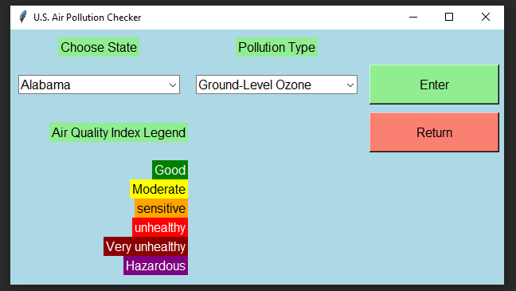Initial GUI if the user wants to select a new option or exit the program.

After selecting the option “Single State Search” the program will create the GUI illustrated above which contains 2 dropdown boxes where the user must select a specific state on the dropdown under the “Choose State” label and the user must select a type of pollution under the “Pollution Type” label. Below the first dropdown box is the AQI index once again and to the right of the pollution type dropdown is a button called “Enter” which will create a bar graph from the selected information. Below this button there is another button named “Return” which will close the current GUI and recreate the Initial GUI if the user wants to select a new option or exit the program.